University Of Azad Jammu & Kashmir, Muzaffarabad


Student Name: Adeela Bashir

Class Rollno: 2024-SE-12

Course Title: Digital Image Processing

Instructor: Sir Fahad Nisar

Date Of Submission: 23-Oct-2026

Department Of Software Engineering
Lab#1

Title: Python Setup, Fundamentals, and Imports

Step 1: Install Python

Python is a programming language used to develop programs and applications. It was installed on the computer to complete the Digital Image Processing lab tasks.

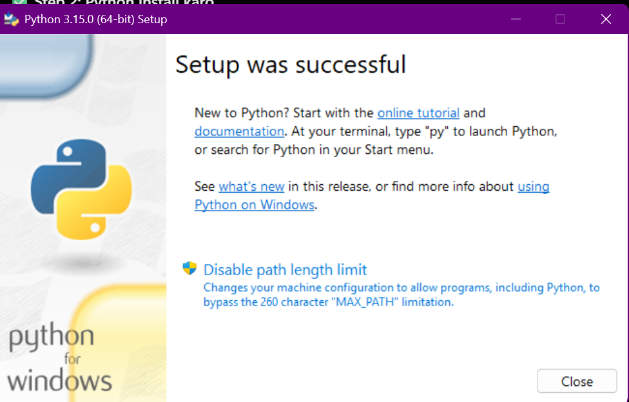

Step 2: Verify Python and pip

The Python and pip versions were checked using Command Prompt. The commands python --version and python -m pip --version were used to verify the installation.

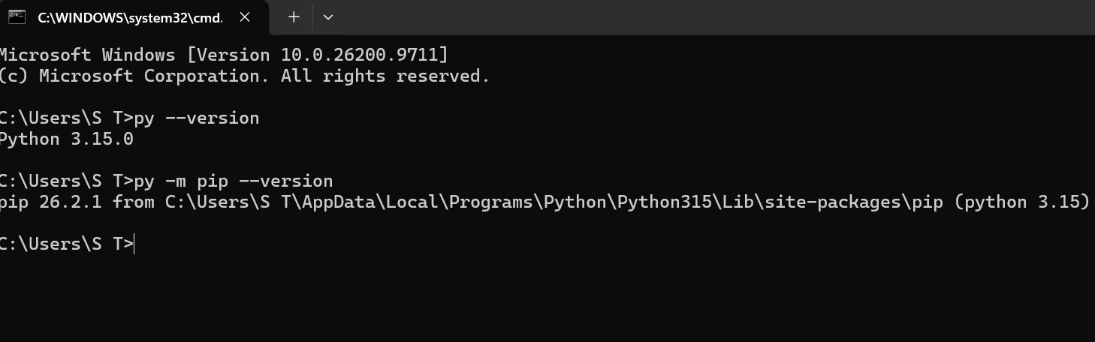

Step 3: Install VS Code and Select Python
Visual Studio Code was used as the code editor for writing and executing Python programs. The Python extension was installed, and the installed Python interpreter was selected to run the programs.

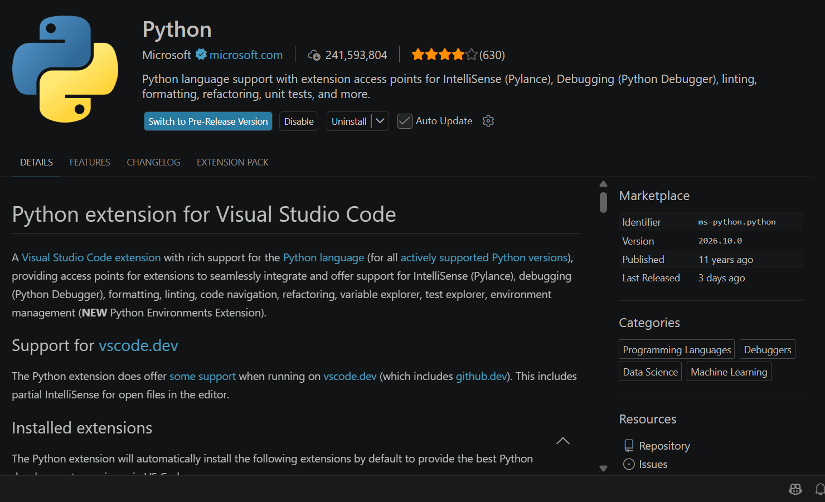

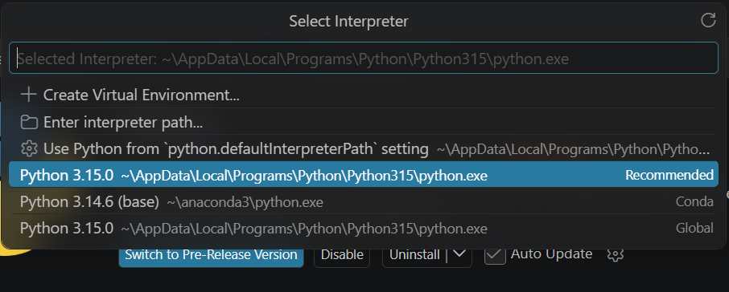

Step 4: Run Your First Python Program
A Python file named hello.py was created in Visual Studio Code. The program displays the message "Hello, Digital Image Processing!" when executed. This task demonstrates how to write, save, and run a basic Python program.

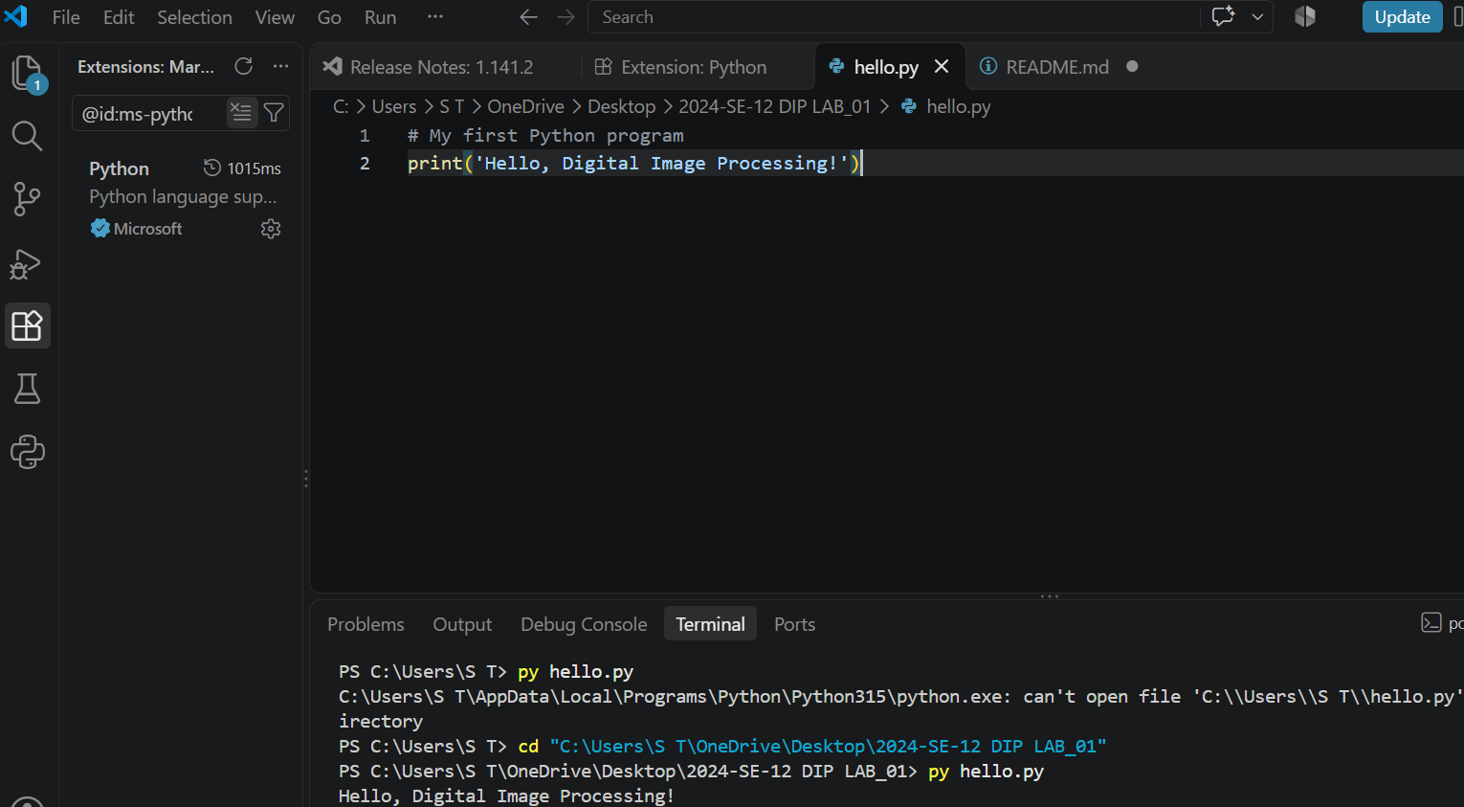

Step 5: Complete Basic Python Exercises
Exercise 1: Variables and Data Types
In this exercise, variables of different data types were created, including integers, a string, and a Boolean value. The values and their data types were displayed using the print() and type() functions. The total number of pixels was calculated by multiplying the image width by its height.

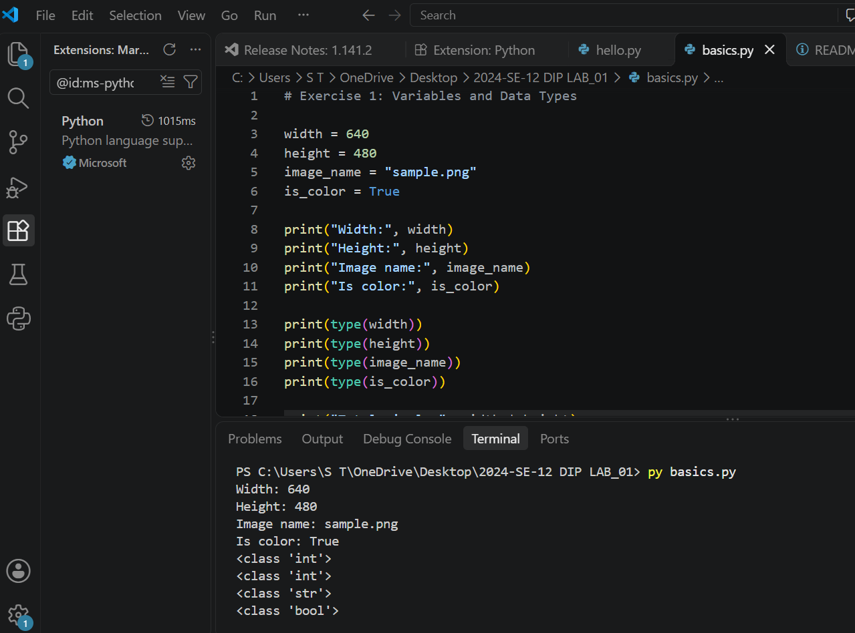

Exercise 2: if, elif, and else

In this exercise, conditional statements were used to classify pixel intensity values. Values outside the range of 0 to 255 were labelled as Invalid. Valid values below 128 were classified as Dark pixel, while values of 128 or above were classified as Bright pixel.

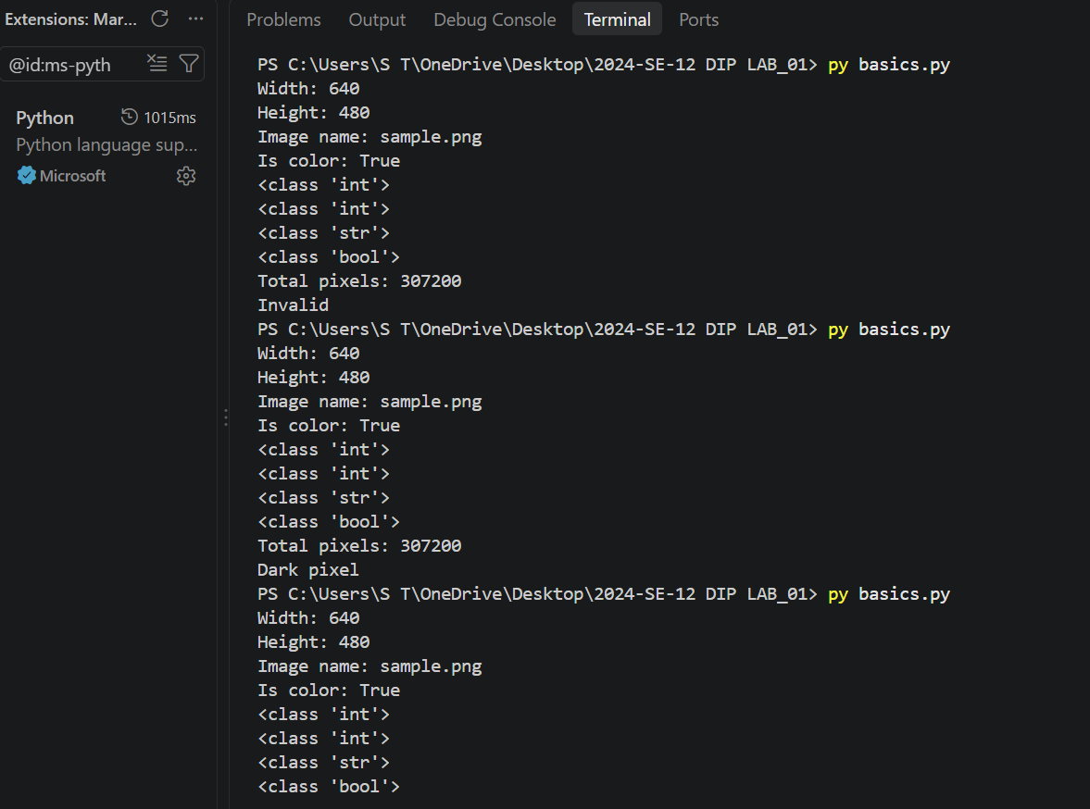

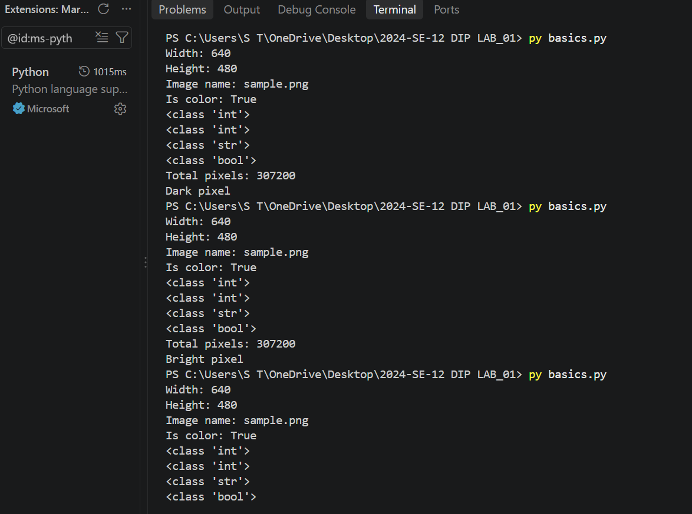
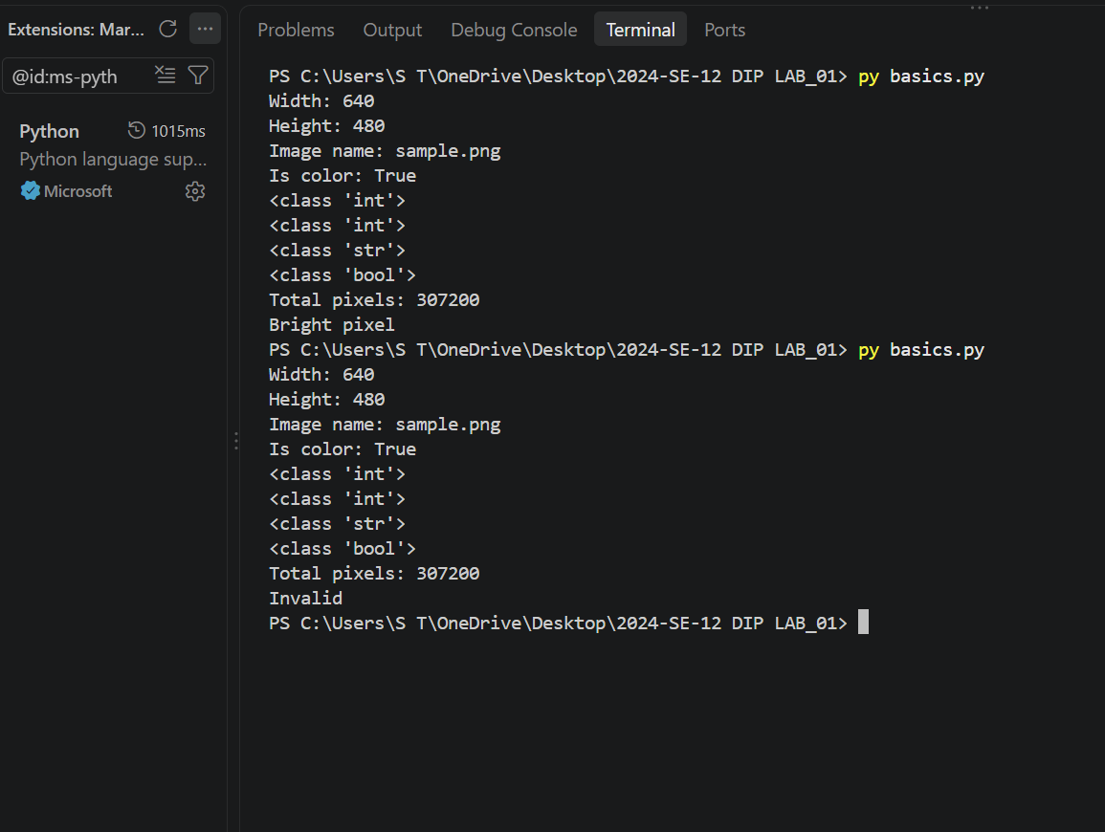

Exercise 3: for and while Loop
A for loop was used to classify pixel values as Bright pixel or Dark pixel using 128 as the threshold. A while loop was also used to print the numbers 0, 1, and 2. The loop counter was updated in each iteration to terminate the loop.

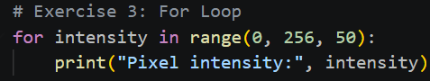
Output
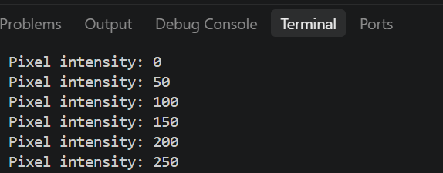
While Loop
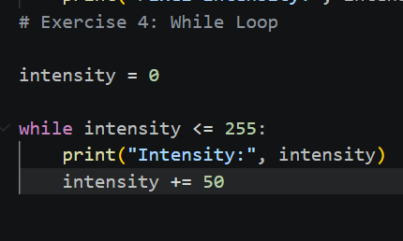
Output
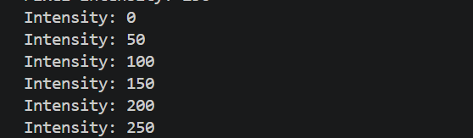
Exercise 4: Functions
A function named is_bright() was defined to determine whether a pixel value meets a given threshold. The function returns True when the pixel value is greater than or equal to the threshold; otherwise, it returns False. The function was tested with different pixel values and thresholds.

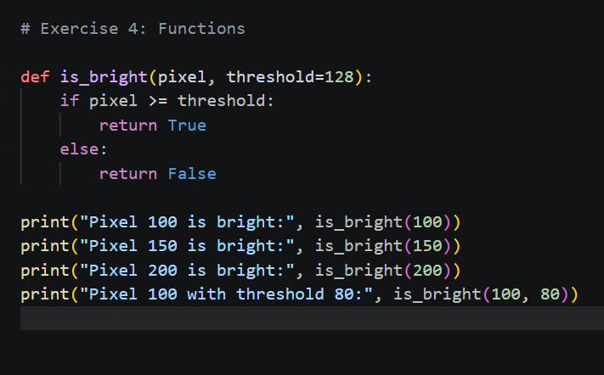
Output

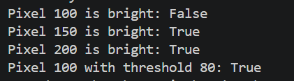
Exercise 5: Lists and Tuples
A list was created and modified by replacing an item and appending a new value. Its length was also calculated. A tuple containing image dimensions was unpacked into width and height variables. Lists are mutable, whereas tuples are immutable.
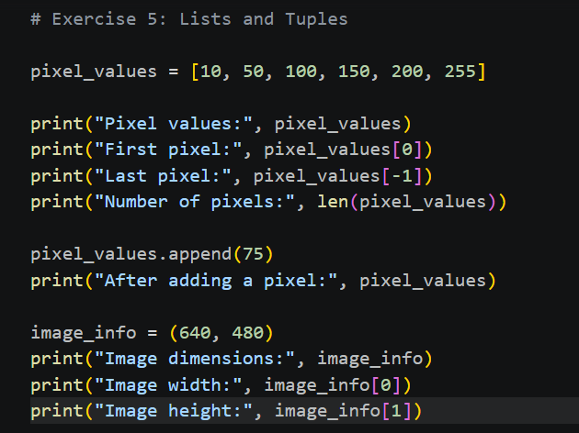
Output
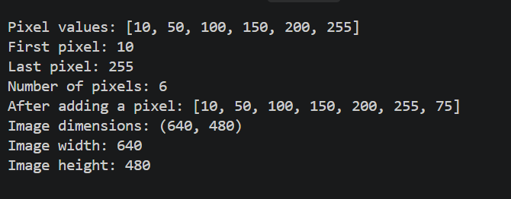
Exercise 6: Dictionaries and Sets
A dictionary was created to store image width and height. A new key named mode was added with the value RGB. A set was created from a list containing repeated labels to identify unique values and calculate their total number.

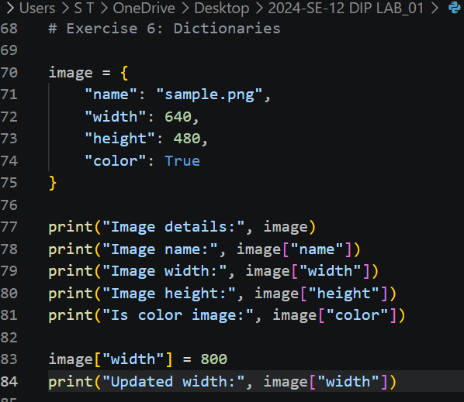
Output

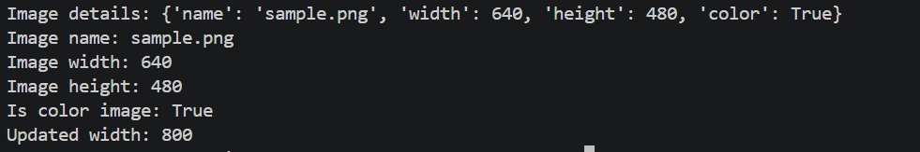

Step 6: Install the Required Packages
The required Python packages NumPy, Pillow, and Matplotlib were installed using pip. NumPy supports numerical operations, Pillow provides image-processing tools, and Matplotlib is used for plotting and visualization. The installation was verified by checking the package information through Command Prompt.
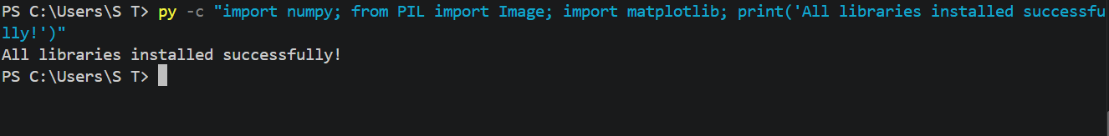

Step 8: Write and Verify Import Statements
A Python file named lab01_imports.py was created to verify the required library imports. NumPy, Pillow, and Matplotlib were imported using their specified import statements. The program executed without errors, confirming that the required libraries were available.

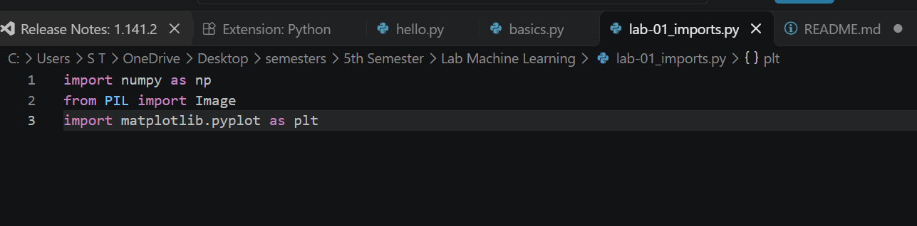

Output

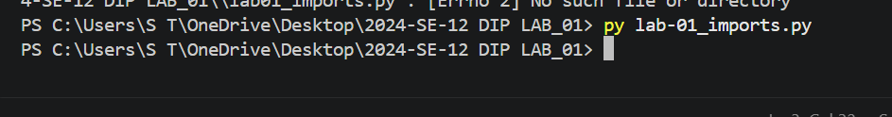

Python Vs Pip Expaination
Python is a programming language used to write and execute programs. Pip is a package installer that helps us install and manage additional Python libraries. Import statements allow us to use functions and features from installed libraries, such as NumPy for numerical operations, Pillow for image processing, and Matplotlib for plotting.

